THE PETER GRAY STORY

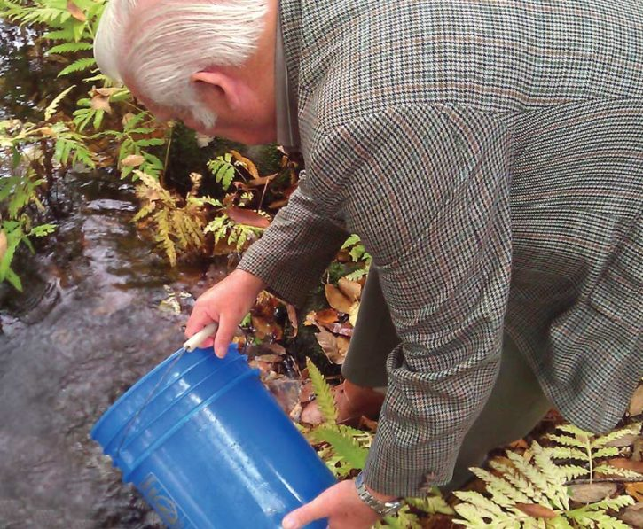
The late Peter Gray was born in 1941 and grew up on the banks of the River Tyne. He was the grandson of a ghillie on the Tweed, and became an angler himself. Gray began fishing for brown trout but quickly found his niche with Atlantic salmon and sea trout.

His 27-year career was spent managing the famous Kielder Hatchery where he played a major role in returning the

River Tyne to one of the finest salmon rivers in England. Gray carried his knowledge and successful efforts to the River Dove. He went on to serve as a consultant and worked with salmon restoration programs across the world.

Gray’s efforts resulted in one of the most impressive wild Atlantic salmon restoration programs in the 170-year history of Atlantic salmon conservation. Salmon returns increased on the River Tyne from 724 to over 13,000 adults. His innovative rearing conditions in his unique streamside hatchery led to strong salmon prepared for survival during their epic oceanic journey.

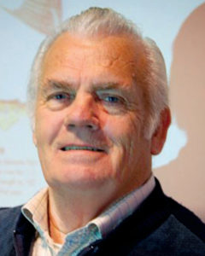
REFLECTING ON A VISIONARY

Gray facilitated the setup and training for the Peter Gray Parr Project at the Downeast Salmon Federation (DSF), which is why the Project is named in his honor. In an interview with Fly Fisherman Magazine, DSF’s Executive Director Dwayne Shaw shared, “Peter’s philosophy was that our hatchery efforts here in America have failed to recover salmon stocks because we’ve been producing inferior fish. He believed we needed to produce ‘little athletes’ with a superior ability to survive, grow, navigate the North Atlantic, and return as healthy adults.”
From custom-designing incubator boxes that allow fish to swim out when they are ready, painting rearing tanks black instead of blue and conditioning fish with increasing water velocities, to using unfiltered water from the very river that holds 10,000 years of evolutionary connection, Gray’s methods continue today. He suddenly passed away in 2012, a year in which the first batch of 81,000 eggs was hatched at the facility now bearing his name, the Peter Gray Hatchery.

